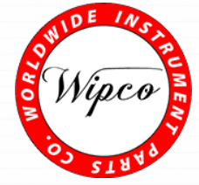

Wipco Quality Policy

Wipco is committed to maintaining the highest level of quality and customer satisfaction and will continually improve upon our quality management system.

Rev. 5

